University of Waterloo Map & Design Library
2001 Census Mapping Methodology
The purpose of this methodology is to explain the process undertaken in creating the 2001census maps for the Kitchener Census Metropolitan Area (CMA) based on Census Tracts (CT) and Dissemination Areas (DA) data. Data utilised was provided by Statistics Canada and is subject to its copyright.

Software Used
ArcGIS 8.1 (ArcMap, Arc Catalogue, Arc Toolbox)
Copyright 1999-2001 by ESRI Inc.
Beyond 2020 Professional Browser 6.0
Copyright 1990-2002 by Beyond 2020 Inc.
Microsoft Excel 2002
Copyright 1985-2001 Microsoft Corporation

Process Steps Overview (click on to advance to section)
- Downloading Census 2001- Profile Series - Beyond 2020 Tables
- Working with Beyond 2020 tables: Preparing Data for use in ArcGIS
- Downloading Census Boundary File
- Working with Data using ArcGIS
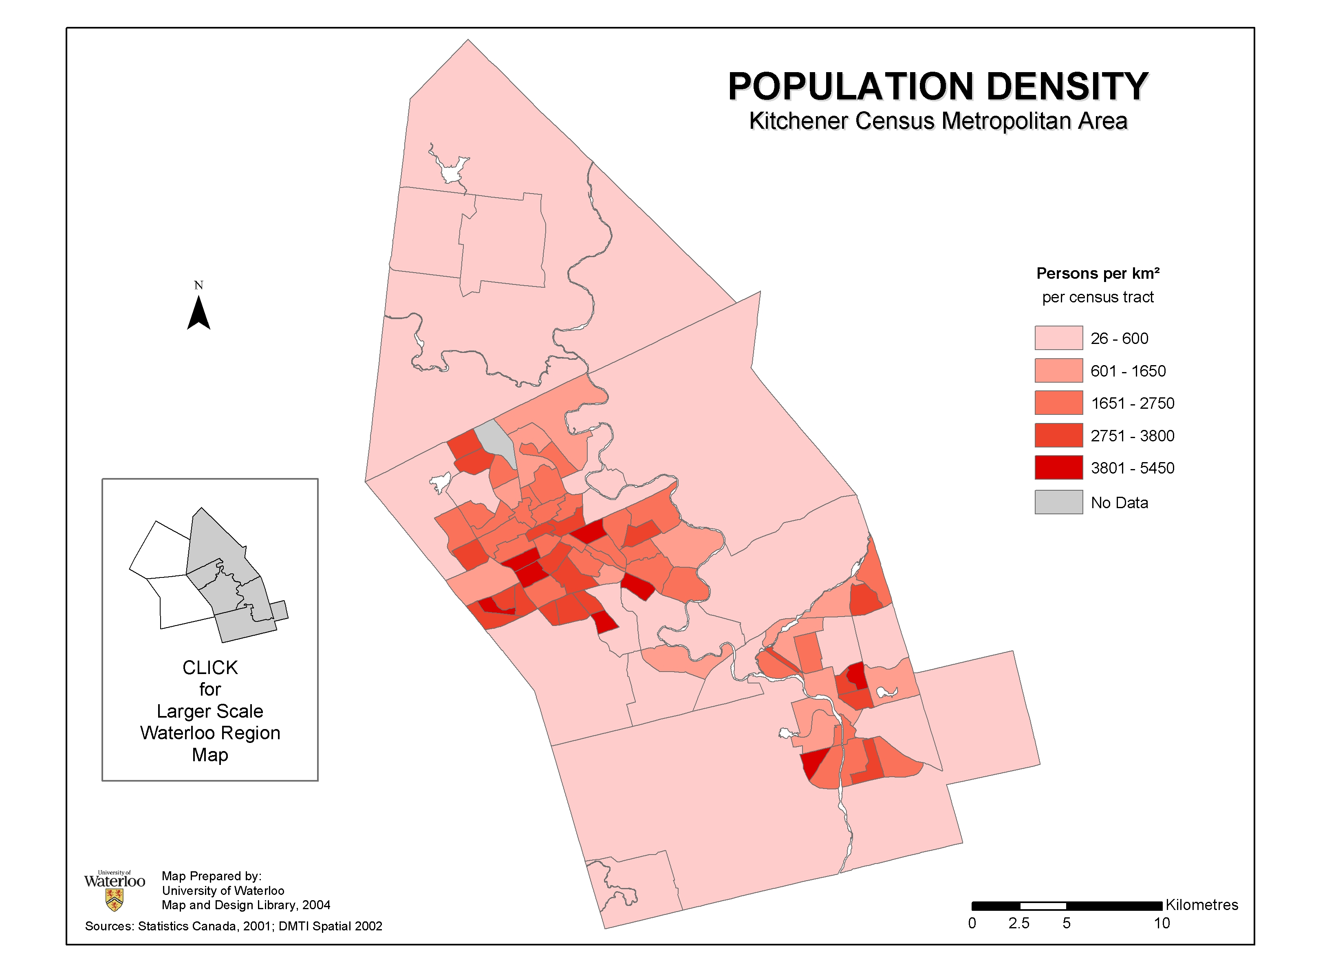

SAMPLE MAP
Process Steps
- Downloading Census 2001- Profile Series - Beyond 2020 Tables*
  - Access the data through the TriUniversity Data Resources (TDR) website http://tdr.tug-libraries.on.ca/ selecting the option webretrieval from TDR Data
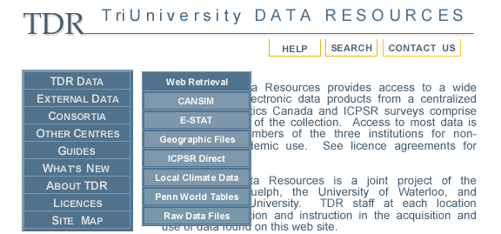
  - Agree to the licensing agreement and select Census of Population Database Group
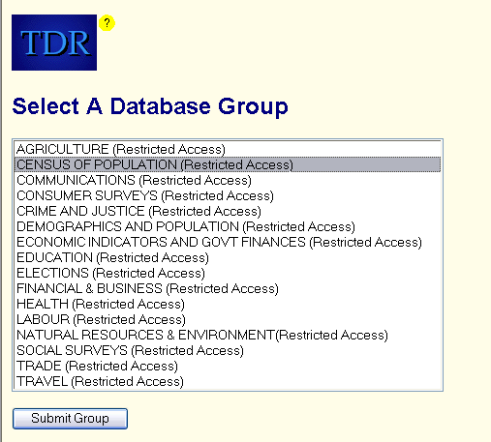
  - select Census 2001 – Profile Series – Beyond 2020 Tables
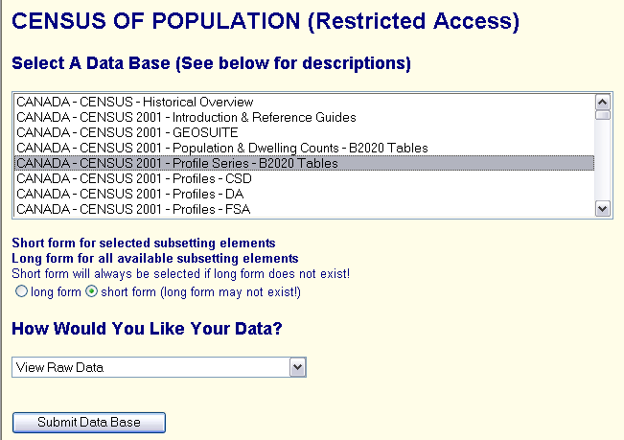

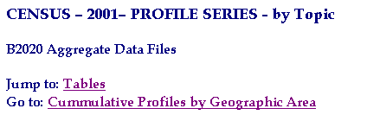
  - tables for downloading are now accessible (the table chosen depends upon the census variables of interest; for most variables they will be included in the cumulative table for Canada or Province of choice)
  - select Cumulative Profiles
  - for CT level variables select table 95F0495XCB01005, for DA level select 95F0495XCB01002
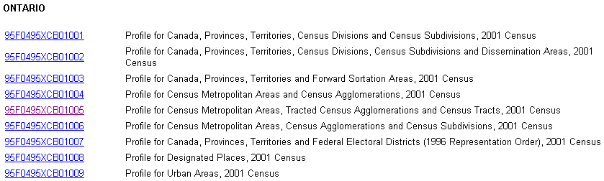
  - download the selected table to a chosen location
- Working with Beyond 2020 tables: Preparing Data for use in ArcGIS
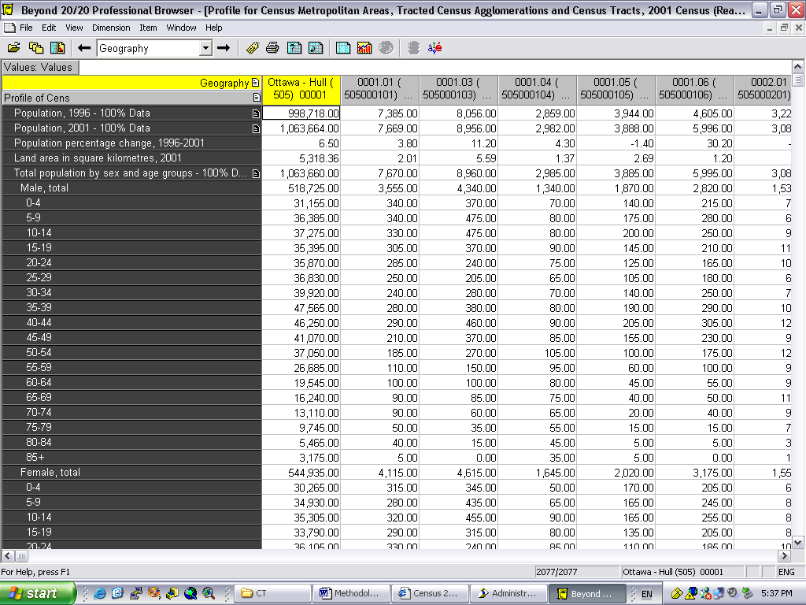
- ArcGIS requires that the Beyond 2020 tables be converted to a dBase (*.dbf) file format
- Open the Beyond 2020 table
- The fields on the top need to be transposed (switched with fields on left)
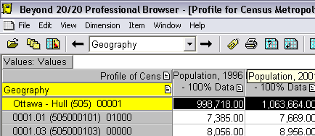
to do this: select the field headings across the top by clicking and drag them to the left side
- Select the CMA data you wish to convert to a .dbf file e.g. Kitchener (Statistics Canada Code: 541) by clicking and dropping down
- From the file menu choose save as dBase (*.dbf) option to chosen location
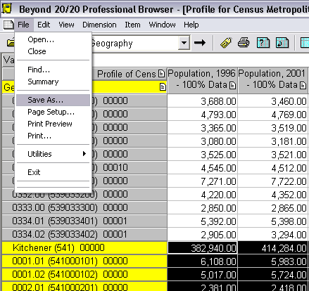
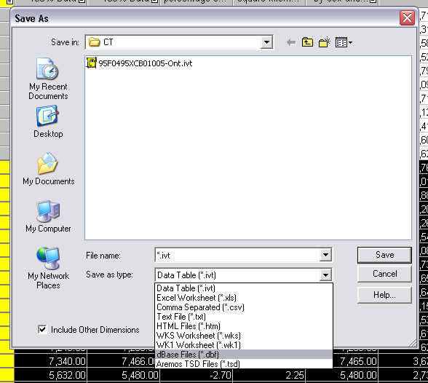
2. Working with Beyond 2020 tables: Preparing Data for use in ArcGIS (continued)
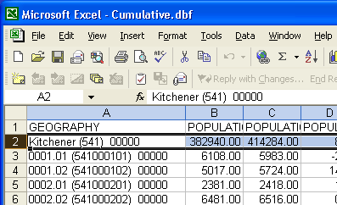
- Open the created dBase (.dbf) file in Microsoft Excel. You will need to modify the table for later use by deleting the entire “Kitchener (541) 00000” row (this data is for the entire CMA and will not join to the boundary file if you need this information, save the file as another name and work with this file in ArcGIS). Next save as DBF 4 (dBase IV) (*.dbf) to allow ArcGIS to read the table
- The new DBF 4 (dBase IV) (*.dbf) requires further manipulation in order for it to be joined (see section 4) to the corresponding census boundary file (see section 3) the table contains the field “GEOGRAPHY” that needs to be edited so that the CMA number codes for the polygon identifier (in brackets) are removed and the identifier numbers are selected out to a new field that will match the corresponding field in the census boundary file (see section 3)
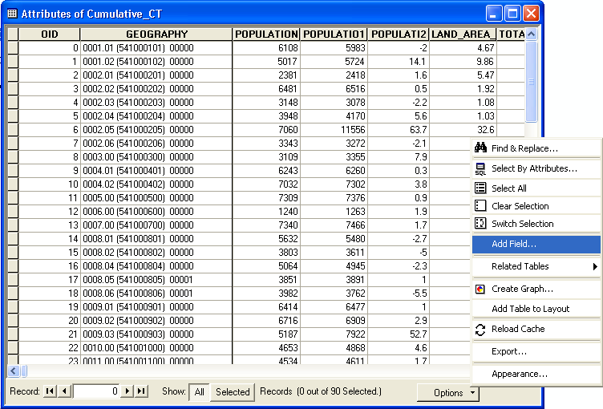
- to perform this manipulation, open the table in ArcMap and add a new field that will hold the new values (in this case the field has been named “Poly_ID”). To do this select the “Options” button and scroll up to “Add Field…”
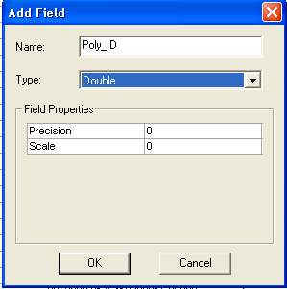
- Next choose the field type “Double” and name your field.
- You are now ready to calculate the new values in your new field. To do this, select your new field by right clicking on its heading and choosing the “calculate values” option
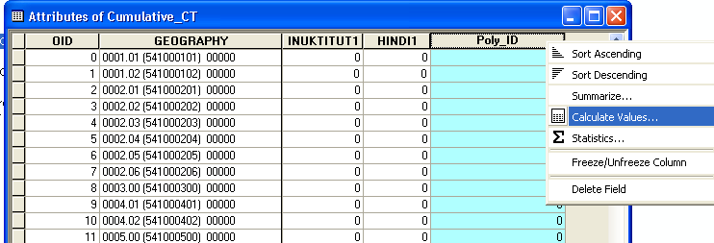
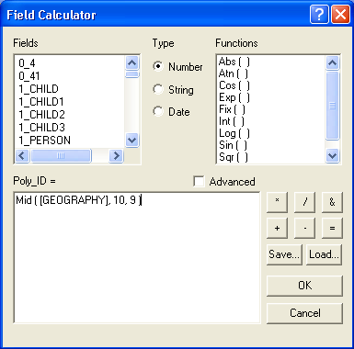
- You will be asked if you want to continue to perform calculations outside of an edit session, choose YES.
Now type in the following formula “Mid ( [GEOGRAPHY], 10, 9 )”
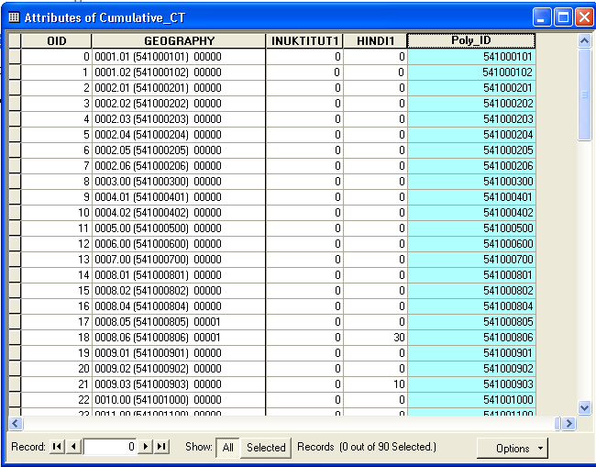
- ArcMap will select out the polygon identifier and return that value as a record in the new field
- The data file is now ready to be joined in ArcMap (see section 4), once you have downloaded and prepared the corresponding census boundary file (see section 3)

- Downloading Census Boundary File*
- Access the data through the TriUniversity Data Resources (TDR) website http://tdr.tug-libraries.on.ca/ selecting the option Geographic Files from TDR Data
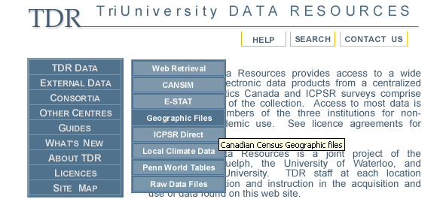

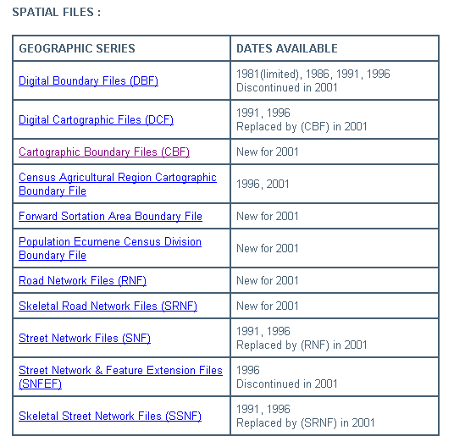
- Scroll down and select CARTOGRAPHIC BOUNDARY FILES
For more detailed information regarding the 2001 cartographic files, refer to Statistics Canada’s Reference Guide - 2nd Edition http://tdr.uoguelph.ca/DATA/CENSUS/2001/GIS01/GEOGFILES/DOCS/reference_guides_de_reference/92f0171gie-cbf-2nd-edition.pdf.
- Scroll down and select the data file CENSUS TRACTS by province, ArcINFO
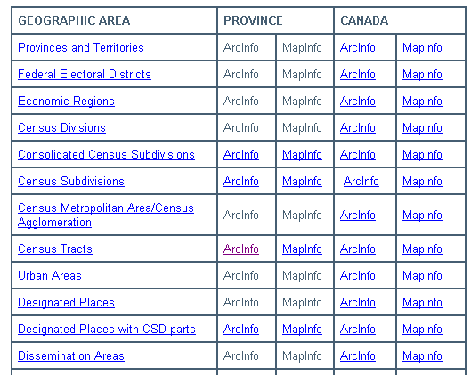
- ArcInfo files are in the ESRI interchange format (*.E00) and will require conversion into coverage file formats (see section 4)

  - Downloading Census Boundary File (continued)
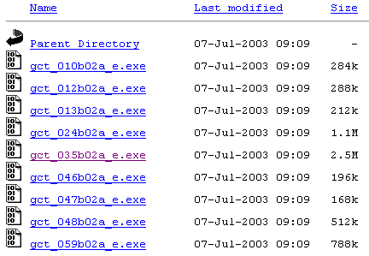
- Select the data file gct_035b02a_e.exe
- Embedded in the file name is the Statistics Canada code for the province of Ontario (35)
- To access these codes and abbreviations used by Statistics Canada visit http://tdr.tug-libraries.on.ca/GEOG/abbrev01.htm
- Download the file to a chosen location *it will become important later on to have a file location without spaces in its pathway, so use underscore “_” when naming your folders and files i.e. C:\Census_Map_Project\Imported_Arc_Info.
- The downloaded file is compressed and needs to be extracted using WinZip, to do this double click on the file icon in windows and choose the file location. WinZip will extract the compressed file into an Interchange File (E00) for further manipulation in Arc GIS (see section 4)
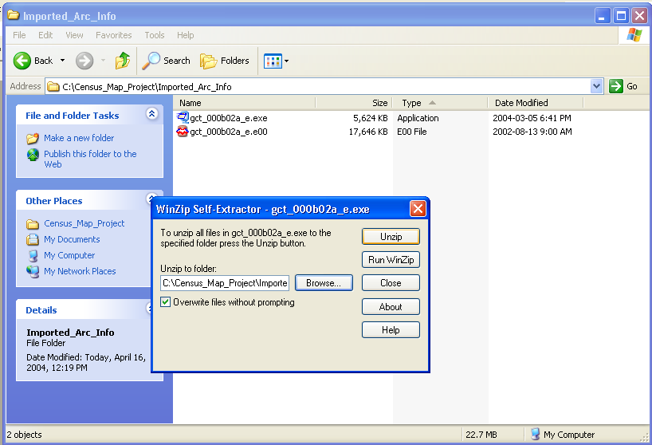
- Working with Data using ArcView ArcGIS
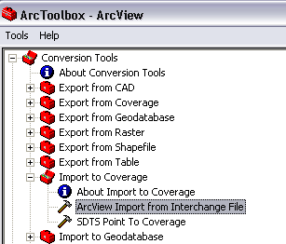
- The extracted data file gct_000b02a_e.e00 needs to be converted from an Interchange File to a coverage file by importing it using Arc Toolbox (which is included in ArcView)
- When choosing the output dataset location, select the same folder that has the downloaded and extracted Interchange file.
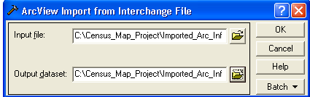
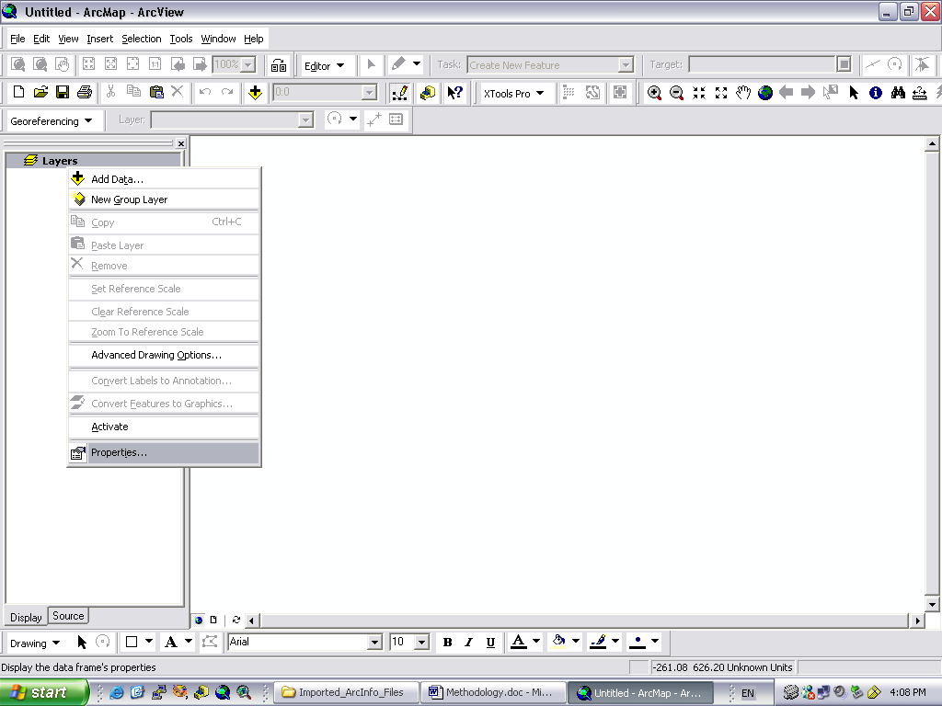
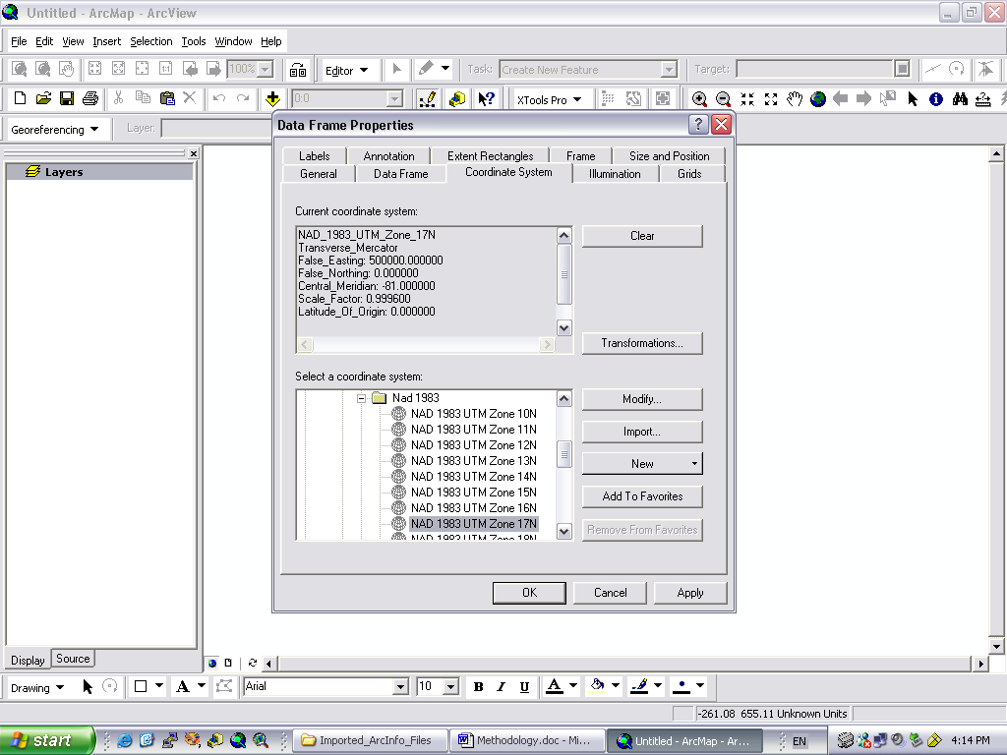
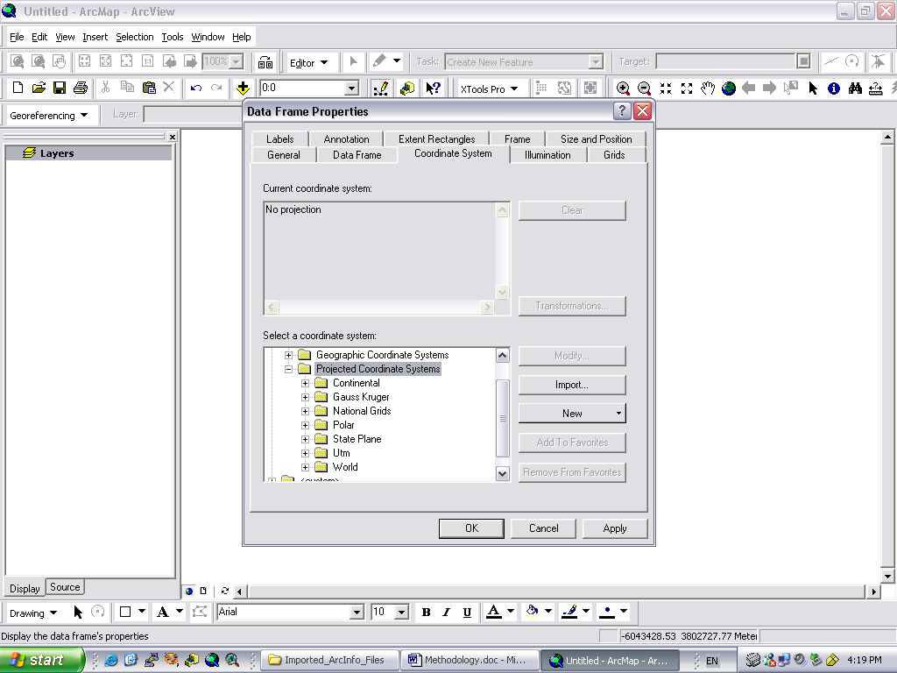
- Before adding the coverage to an open ArcMap application you must first define the projection for the Layer to UTM NAD 1983 zone 17N, to do this open the Layer’s Data Frame properties and select Coordinate Systems, now choose Predefined Projected Coordinate Systems
  - Working with Data using ArcView ArcGIS (continued)
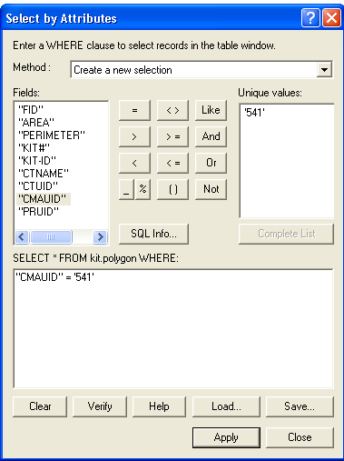

- The new coverage can now be added into an open ArcMap application

- Kitchener CMA (census code 541 in the field CMAUID) has to be selected out from the new coverage and a new layer created from the selection

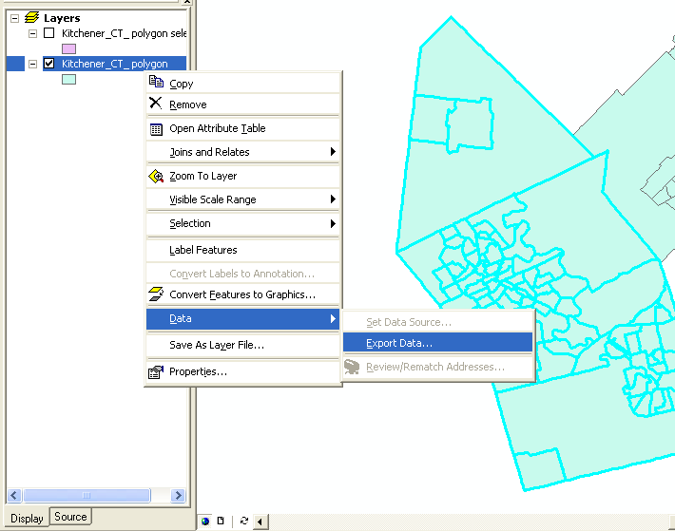
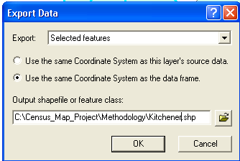
- The new selected layer should now be converted to a shapefile by exporting it using the data frame coordinate system to allow for editing of the table i.e. adding a new field
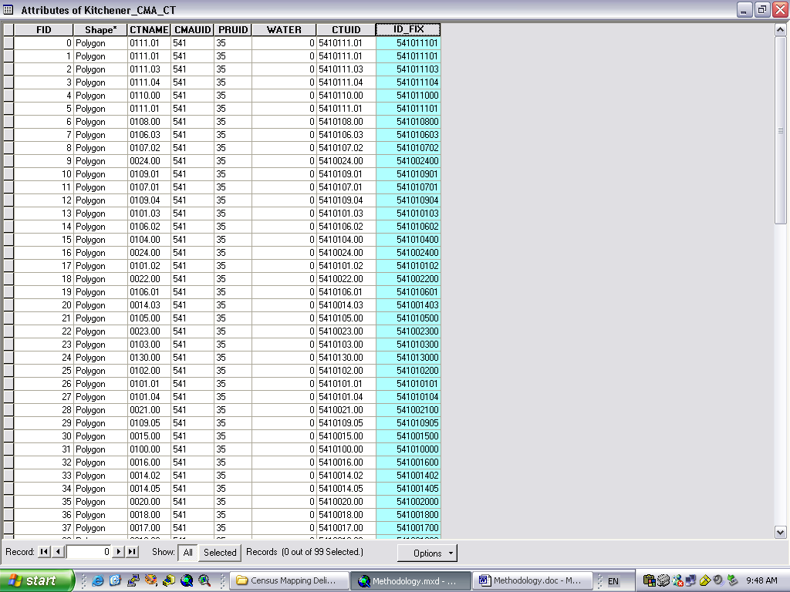
- The new shapefile needs to be edited so that the field CTUID will match the modified census DBF 4 (dBase IV) (*.dbf) table (see section 4 k) by removing the decimal and last two digits

- To perform this manipulation, you will need to add a new field (in this case the field has been named “ID_FIX”) as you previously did (see section 2 h)
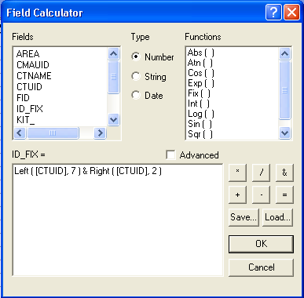
- Next you will need to calculate values as you did previously, only this time the formula is as follows:
“Left ( [CTUID], 7 ) & Right ( [CTUID], 2 )”
- The modified boundary file is now ready to be joined
- Add the modified census DBF 4 (dBase IV) (*.dbf) table to the open ArcGIS application
  - Working with Data using ArcView ArcGIS (continued)

- The boundary file needs to be joined to the modified census DBF 4 (dBase IV) (*.dbf) table so the information can be displayed spatially using the join function by selecting the edited boundary file with a right click and scrolling down to Joins and Relates, the join will be based on the two created fields containing the CTUID in its edited form
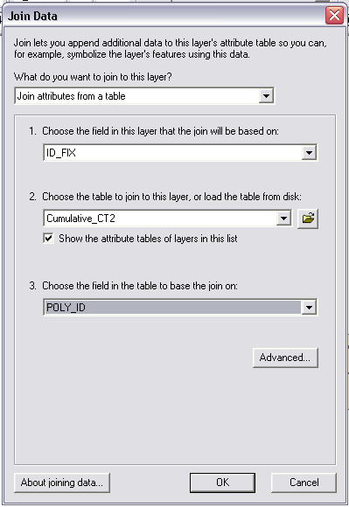
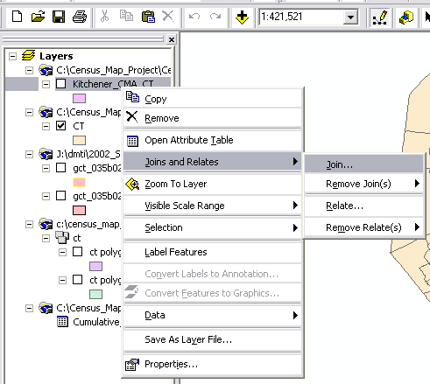
- Once the join is successfully performed, the census data is ready for thematic mapping based on the desired variables (see Derivation of Map Variables and Reading and Referencing a Census Map Documents)
- The newly joined boundary file can be exported as a new shapefile so as to simplify map generation by making the table easier to read
  - Working with Data using ArcView ArcGIS (continued)
- An example of a thematic map for the variable Population Density is shown, to calculate the variable a new field was created based on the variables total population and land area (see Derivation of Map Variables)

